Exp no: 7
Roll no: 241001314

Unification and Resolution – Exercises with Solutions

Exercise 1: Sentence Matcher
% Facts sentence(the_cat_sits). sentence(the_dog_runs).
% Query
% ?- sentence(X).
Output:
X = the_cat_sits ; X = the_dog_runs ; false.

Exercise 2: Compound Term Unification
% Facts likes(john, food(pizza, spicy)). likes(mary, food(pizza, sweet)).
% Query
% ?- likes(john, food(pizza, T)).
Output:
T = spicy.

Exercise 3: Conflict Resolution % Facts rule1(climate_change). rule2(climate_change). % Rule conflict(X) :- rule1(X), rule2(X).
% Query
% ?- conflict(climate_change).
Output: true.

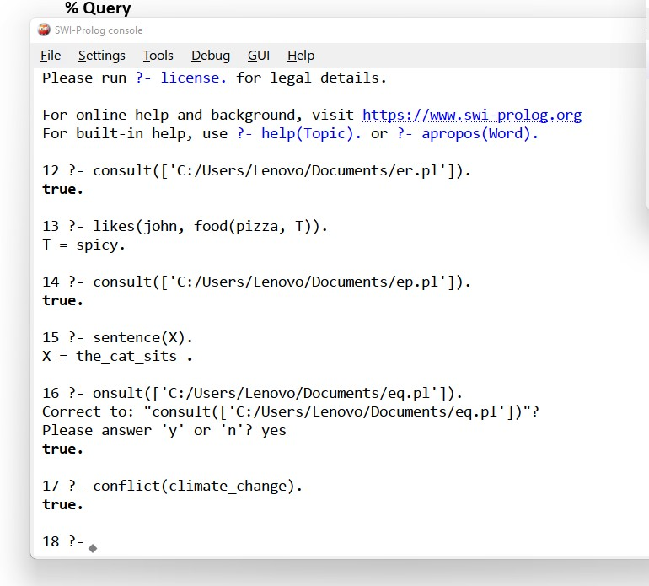

Result:
Thus the programs in prolog has been executed and the output is verified successfully.

